

**CAPSTONE PROJECT REPORT**

**Report 1 – Project Introduction**

– Hanoi, April 2025 –

**Table of Contents**

I. Record of Changes 3

II. Definition and Acronyms 4

III. Project Introduction 4

1. Overview 4

1.1 Project Information 4

1.2 Project Purpose 4

1.3 Project Stakeholders 4

2. Product Background 5

3. Existing Solutions 6

3.2 Pickleball Booker 7

4. Solution & Opportunity 8

4. Solution & Opportunity 8

5. Project Scope & Limitations 9

5.1 Major Features 9

5.2 Limitations & Exclusions 13

# I. Record of Changes

| **Date** | **A* M, D** | **In charge** | **Change Description** |
| --- | --- | --- | --- |
|  |  |  |  |
|  |  |  |  |
|  |  |  |  |
|  |  |  |  |
|  |  |  |  |
|  |  |  |  |
|  |  |  |  |
|  |  |  |  |
|  |  |  |  |
|  |  |  |  |
|  |  |  |  |
|  |  |  |  |
|  |  |  |  |

*A - Added M - Modified D - Deleted

# II. Definition and Acronyms

| **Acronym** | **Definition** |
| --- | --- |
| BR | Business Rule |
| ERD | Entity Relationship Diagram |
| SRS | Software Requirement Specification |
| SDS | Software Design Specification |
| UT | Unit test |
| ST | System Test |
| IT | Integration Test |
| UC | Use Case |

# III. Project Introduction

## 1. Overview

### 1.1 Project Information

* Project name: **Pickleball Court Management System**
* Project code: **PBS**
* Vietnamese name: **Hệ thống quản lý sân Pickleball**
* Group name: **SEP490_G9**
* Software type: **Web application, Mobile application**

### 1.2 Project Purpose

This Pickleball Court Management System is designed specifically for individual owners who own multiple courts, providing a comprehensive solution to monitor and optimize operations: from scheduling usage, monitoring the actual status of each court (in use, empty, maintenance) to managing membership profiles and automatic payments, and automatically compiling reports on usage frequency and revenue. The player booking feature is just a small part of the support, to ensure an improved user experience, the system helps owners proactively control, allocate resources and make reasonable decisions to increase exploitation efficiency, reduce operating costs and maximize profits. This document is intended as a guide and intended goal for the implementation of the various functions of the system, ensuring that the final product meets the needs of both individual owners who own multiple courts and players in the growing sport of pickleball.

### 1.3 Project Stakeholders

| **Full Name** | **Role** | **Email** | **Mobile** |
| --- | --- | --- | --- |
| Nguyen Quang Hung | Supervisor | hungnq40@fe.edu.vn | 0919684368 |
| Le Ba Hai Ha | Leader | halbhhe176636@fpt.edu.vn | 0352565658 |
| Le Ba Ha | Member | halbhe176637@fpt.edu.vn | 0332526273 |
| Nguyen Van Ruan | Member | ruannvhe160301@fpt.edu.vn | 0981604658 |
| Tran Quoc Viet | Member | viettqhe161146@fpt.edu.vn | 0867990063 |

## 2. Product Background

In recent years, Pickleball – a sport that blends elements of tennis, badminton, and table tennis – has started to gain attention in several urban areas across Vietnam. Although it is still relatively new and not yet widely popular, Pickleball has gradually attracted a growing community due to its simplicity, accessibility, and suitability for a wide age range, especially middle-aged and older players.

However, as the sport slowly expands, the organization and management of pickleball courts in Vietnam remain highly informal and fragmented. Most courts, whether located in residential areas, schools, or community sports centers, are still operated manually using traditional methods such as: Paper-based sign-up sheets, Direct phone calls or messaging via Zalo, Facebook, or SMS, Group chats for managing time slots, Word-of-mouth for schedule coordination,...

These manual approaches often lead to numerous problems: double bookings, poor transparency in payments, players unaware of available time slots, and court owners struggling to keep up with requests and scheduling.

For new players or casual participants, booking a court can be frustrating, especially if they are not connected to existing groups or communities. Likewise, for small or independent court owners, manually juggling bookings, payments, customer support, and daily coordination becomes a time-consuming and error-prone task.

These practical frustrations naturally raised a simple but important question:  
 Is there a better way to help court owners manage bookings more easily and efficiently, while also giving players a clearer, more convenient way to reserve courts?

From this question – not inspired by trends abroad, but rather from real, day-to-day struggles happening locally – the idea of building a Pickleball Court Management System began to take shape.

## 3. Existing Solutions

3.1 AllBooked by Skedda   
 Link: [Skedda](https://www.skedda.com/solutions/pickleball-court-booking)   
**Description**:  
 AllBooked by Skedda is an online pickleball court booking system designed to help facilities manage their courts efficiently, optimize schedules, and increase revenue from their spaces. The system provides tools for managing court bookings, setting up pricing, and automating manual tasks. AllBooked by Skedda involves the following main system actors:

* **Facility Administrators**: Manage booking schedules, set pricing and booking rules, and track facility performance and revenue.
* **Players**: Use the system to view court availability, book courts easily online, and manage their bookings.

AllBooked by Skedda is designed to streamline facility management and control operations through the following key features:

* **Online Court Booking Management**: Provides an intuitive interface for players to view availability and book courts anytime, anywhere.
* **Schedule Management**: Enables administrators to manage the operating schedule of courts and maximize utilization.
* **Flexible Pricing**: Supports the setup of flexible pricing rules (e.g., based on time, day of the week) to optimize revenue.
* **Integrated Payments**: Allows for the integration of online payment methods, simplifying the collection of court booking fees.
* **Workflow Automation**: Supports the creation of custom booking rules, booking quotas, integration with other systems, and the setup of recurring bookings to reduce manual work.

AllBooked by Skedda delivers specific benefits for each user group:

* **For Facility Administrators**: Simplifies booking and schedule management, optimizes revenue through flexible pricing, and reduces manual work through automation.
* **For Players**: Provides an easy and convenient way to find and book courts that fit their schedule anytime, anywhere.

Based on the website information, AllBooked by Skedda may have several aspects that warrant further consideration:

* **Level of Customization**: While the website highlights key features, the extent of customization for specific facility needs may require further investigation.
* **Advanced Player Management Feature**s: Although it offers booking management, more detailed player profile management or community integration features might require further exploration.
* **Detailed Reporting and Analytics**: The website mentions performance tracking, but more information about the types of reports and advanced analytics capabilities may be needed for a full assessment.

### 

### 3.2 Pickleball Booker

**Link:** <https://pickleballbooker.com/>

**Description:** Pickleball Booker is an online pickleball court reservation software designed to help facilities manage their courts efficiently. It offers a clean and simple interface with powerful calendar scheduling features, enabling facilities to handle all online appointment bookings effectively. ​Pickleball Booker

**System Actors:**

* **Facility Administrators:** Manage booking schedules, set up pricing and booking rules, and track facility performance and revenue.​
* **Players:** Use the system to view availability and book courts online easily, and manage their bookings.​

**Key Features:**

* **Online Court Booking Management:** Provides an intuitive interface for players to view availability and book courts anytime, anywhere.​
* **Schedule Management:** Allows administrators to easily manage the operating schedule of courts and maximize utilization.​
* **Flexible Pricing:** Supports setting up pricing based on various rules (e.g., by time, day of the week) to optimize revenue.​
* **Integrated Payments:** Enables the integration of online payment methods, facilitating the collection of court booking fees.​
* **Workflow Automation:** Supports the creation of custom booking rules, booking quotas, integrations with other systems, and setting up recurring bookings to minimize manual work.​

**Benefits:**

* **For Facility Administrators:** Simplifies the management of bookings and schedules, optimizes revenue through flexible pricing, and reduces manual tasks through automation.​
* **For Players:** Easily find and book courts that fit their schedule anytime, anywhere, providing a convenient booking experience.​

**Considerations:**

* **Level of Customization:** While the website highlights key features, the extent of customization for specific facility needs may require further investigation.​
* **Advanced Player Management Features:** While it offers booking management, more detailed player profile management or community integration features may need further exploration.​
* **Detailed Reporting and Analytics:** The website mentions performance tracking, but details on the types of reports and advanced analytics capabilities may need clarification.

## 4. Solution & Opportunity

* The sports and recreation industry—particularly in emerging sports like pickleball—is growing rapidly and requires better digital solutions for scheduling, facility operations, and customer experience. Many small to mid-sized sports centers still rely on manual methods such as phone-based reservations, in-person sign-ups, and paper-based booking logs. These outdated methods often lead to issues such as double bookings, miscommunication, lack of transaction history, and poor customer service.
* While large sports complexes may already use customized booking systems, the vast majority of community-based or privately owned facilities lack access to affordable and tailored management platforms.
* Realizing this gap, the Pickleball Court Management System was developed to provide an accessible, centralized, and smart solution for both players and facility operators. The system supports both web and mobile platforms, enabling full visibility and control over reservations, court availability, customer service, payment processing, and maintenance scheduling—all in real time.
* By integrating key technology solutions into one system, the platform helps:
  + Save time for both users and staff by automating scheduling and payments
  + Increase accuracy and transparency in financial reporting
  + Improve customer experience through real-time availability, fast booking, and instant confirmation
  + Optimize facility operations, reducing overbooking, missed payments, or service delays
* In the future, the Pickleball Court Management System aims to fully replace traditional processes and become an essential tool in the daily operations of court-based sports facilities. It is particularly valuable for newly launched or growing businesses, helping them build credibility, trust, and convenience in the eyes of their customers while maintaining efficient internal management.

## 5. Project Scope & Limitations

### 5.1 Major Features

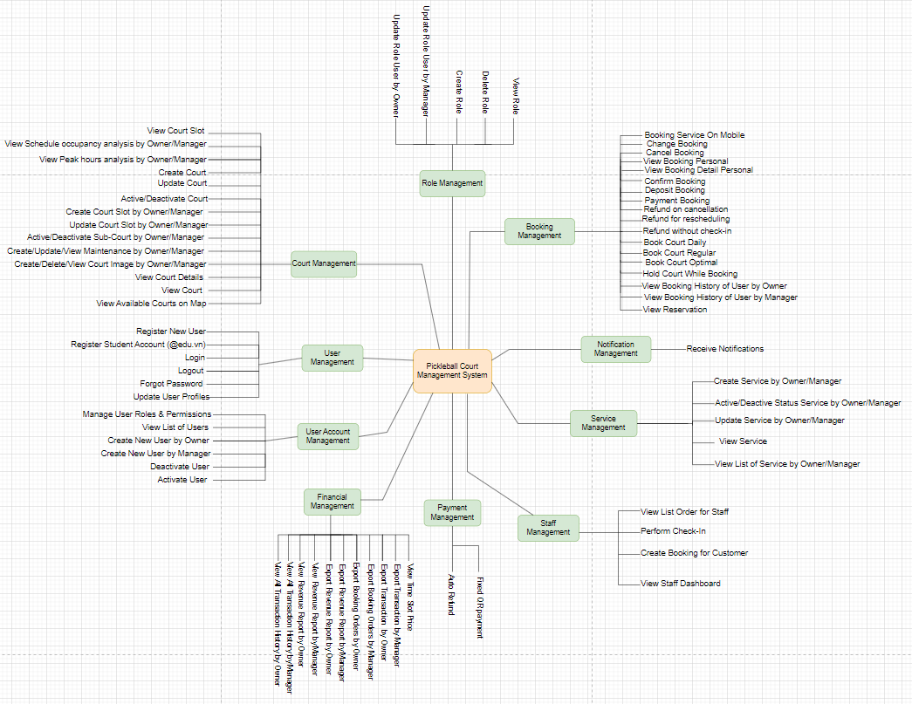

**FE-01: Court Management**

* **View available courts on an interactive map:**  Users and guests can search and view courts based on real-time availability, location, and court type.
* **Create, update, activate, and deactivate courts:** Administrators (Owner, Manager) can add new courts, update court details (e.g., type, location, pricing), and manage court availability status.
* **Manage sub-courts for flexible booking:** Configure large courts into multiple smaller courts to optimize usage.
* **View detailed court information:** Including court images, descriptions, locations, availability schedules, maintenance records, and peak usage analysis.
* **Manage court maintenance schedules:** Plan and monitor court maintenance periods to ensure optimal playing conditions and avoid disruptions.

**FE-02: User Management**

* **Register new user accounts:** Allow users and students (with verification via @edu.vn email) to create accounts.
* **Manage user profiles:** Users can update personal information such as first name, last name, birthday, and profile picture.
* **User authentication and login:** Secure login process with password authentication.
* **Password recovery:** Allow users to reset forgotten passwords by receiving a new random password via email.

**FE-03: Booking Management**

* **Create and view bookings:** Users can book available courts and services, and view their booking history.
* **View booking details:** Full booking information including court, time, service type, payment status, and timestamps.
* **Handle deposits and payments:** Users can make deposits or full payments using QR codes.
* **Confirm, cancel, and reschedule bookings:** Users can confirm, cancel (with applicable refund rules), or reschedule bookings.
* **Suggest optimal courts:** The system recommends alternative courts based on user preferences and availability.
* **Hold courts temporarily during booking:** Courts are temporarily locked to prevent overlapping bookings while a user completes the payment.

**FE-04: Notification Management**

* **Send booking and payment notifications:** Notify users of booking confirmations, changes, cancellations, and payment updates.
* **Notification channels:** Email and in-app/web notifications to keep users informed.

**FE-05: Pricing Management**

* **Create and manage pricing structures:** Different prices based on weekdays, weekends, holidays, and user types (students, guests).
* **Update and view time slot prices:** Allow flexible pricing management for specific courts and times.
* **Export pricing and revenue reports:** Generate reports for operational and financial analysis.

**FE-06: Payment & Financial Management**

* **View transaction history:** Complete records of deposits, full payments, and refunds.
* **Manage financial data:** Monitor and export all financial records for reporting, auditing, and cash flow tracking.
* **Export financial reports:** Export transaction and revenue data in Excel (.xlsx) format.

**FE-07: Service Management**

* **Create and manage services:** Set up services like coaching sessions, equipment rental, food, and beverages.
* **Activate/deactivate services:** Control the visibility and availability of services dynamically.
* **View service information:** Display service details during the booking process.

**FE-08: Staff Management**

* **Access staff dashboard:** Staff can view daily bookings, service orders, and check-in statuses.
* **Create bookings on behalf of customers:** Allow staff to create manual bookings for walk-in customers or phone reservations.
* **View and manage order lists:** Organize and prepare for upcoming bookings and service deliveries.
* **Perform customer check-ins:** Confirm customer arrival and ensure operational smoothness.

**FE-09: Role Management**

* **Update user roles by Owner:** Owners can assign or modify user roles (Owner, Manager, Staff, User, Student).
* **Update user roles by Manager:** Managers can assign or modify roles for Staff, User, and Student accounts within their scope.
* **Create new roles:** Owners can define custom roles beyond the default ones.
* **Delete roles:** Remove unused or unnecessary roles if no user is assigned to them.
* **View roles:** View the list of all roles available in the system and their assigned permissions.

**FE-10: User Account Management**

* **View all registered users:** Search, filter, and view detailed user profiles including roles and account status.
* **Create new users by Owner:** Owners can manually create accounts for Managers, Staff, or Users.
* **Create new users by Manager:** Managers can create Staff or User accounts under their assigned responsibility.
* **Deactivate user accounts:** Temporarily lock a user's access to the system.
* **Activate user accounts:** Reactivate a user's access to the system when necessary.

### 5.2 Limitations & Exclusions

**LI-01: Player Matching Constraints**

* The system offers suggestions for player matching based on skill level and availability for doubles or group matches.
* However, successful matching may be limited due to differences in player preferences, availability, or scheduling conflicts, especially during off-peak hours.

**LI-02: No Social Media or Marketing Integration**

* The system does not support integration with external social media platforms (e.g., Facebook, Instagram, Zalo).
* Course managers must manually handle all promotional activities outside the system.

**LI-03: No Customer Feedback or Review System**

* The system currently does not allow players to submit comments, ratings, or detailed reviews about courts, services, or staff.
* As a result, managers cannot collect structured feedback or ratings to assess user satisfaction or prioritize service improvements.

**LI-04: No Event or Tournament Management**

* The system does not support organizing tournaments, meetups, or training programs.
* Players cannot register for such events via the system, and administrators cannot create brackets, manage participant lists, or track tournament results.

**LI-05: No Loyalty or Rewards Program**

* The system lacks a loyalty or points-based reward program to encourage frequent usage.
* Players do not earn points or rewards for frequent bookings, potentially reducing retention compared to competing facilities offering such incentives.

**LI-06: No Multi-Currency or International Payment Support**

* The system does not support international payment options such as PayPal, Stripe, or international credit cards.
* Payments are limited to local Vietnamese banking methods, creating challenges for foreign players or tourists who want to book remotely.